TRAVEL TIPS FOR MONGOLIA

Mongolia is a far-flung, little visited destination, with much to offer in terms of scenery, wildlife, and historic and cultural sites. Outside the main cities, Mongolians continue to live the traditional life of malchin (herdsmen), and many are nomadic. With one of the world’s lowest population densities, Mongolia’s vast areas of wilderness, desert, lakes and mountains offer plenty of scope for adventurous outdoor enthusiasts. Although independent travel is now becoming more common, travel outside the capital is usually by prior arrangement.

Visa The visa is to be obtained prior to arrival in the country

Main Airports:
Ulaanbaatar (ULN) (Chinggis Khaan) is 15km (9 miles) from the city.
To/from the airport: Buses run to the city center (journey time – 30 minutes). Taxis are also available (journey time – 15 minutes).
Facilities: Bank, duty-free shops, car hire, post office and a restaurant.
Getting There by Air:
The national airline is Mongolian International Air Transport (MIAT) (OM)

Getting Around by Rail:
There are 1815km (1127 miles) of track. The main line runs from north to south: Sukhbaatar–Darkhan–Ulaanbaatar–Sainshand. Branch lines serve the principal industrial regions.
Getting Around by Road:
Paved roads are to be found only in or near major cities.
Bus: There are frequent bus services between major towns, but the roads are mostly unpaved.
Getting Around Towns and Cities:
There are frequent bus and trolleybus services in the city.
Journey Times:
The following chart gives approximate travel times (in hours and minutes) from Ulaanbaatar to other major cities/towns in Mongolia.

Ulaanbaatar | Air | Road
Erdenet | 0.45 | 9.00
Dalanzadgad | 1.20 | 14.00
Darkhan | - | 5.00
Khovd | 4.00 | 4/5 days

Language:
Khalkh Mongolian is the official language. Kazakh is spoken by 5 per cent of the population. There are also many Mongolian dialects.
Religion:
Buddhist Lamaism is the main religion, although there is no state religion.’

Electricity:
230 volts AC, 50Hz.

Climate:
A dry climate with short, mild summers and long, severe winters (October to April). Some rain falls during summer and there is snow during winter.
There are four well-defined seasons, and on average, the sun shines for well over 200 days a year. The climate is harsh continental with low precipitation. The temperature varies greatly within the year; the same phenomenon may also occur within a day.
The last 60 years of meteorological observation show annual average temperatures of 8.5C in the Gobi and -7.8C in the mountains. The extreme minimum temperature is between 31.1C below zero and 52.9C below zero in January. The extreme maximum temperature is between 28C and 43.1C in July. Annual precipitation is low, averaging 200-220mm, ranging from under 50mm in the extreme south (Gobi desert) tom 400mm in limited areas in the north. Most precipitation occurs in June, July and August, and the driest months are November to March.
Required Clothing
Medium weights are worn during summer, with very warm heavyweights advised for winter.

Tipping: Not customary, if leaving a tip, 10 per cent is the norm.

Currency Information:
Tugrik (MNT). Notes are in denominations of MNT10,000, 5,000, 1,000, 500, 100, 50, 20, 10, 5 and 1. Coins are in denominations of MNT500, 200, 100, 50 and 20.
Currency Exchange
Official organizations authorized to exchange foreign currency include commercial banks in Ulaanbaatar and bureaux de change at certain hotels. The easiest currency to exchange is the US Dollar.
Credit/Debit Cards and ATMs
Accepted by main commercial banks, large hotels and a few shops and restaurants in Ulaanbaatar. Credit card cash advances can be obtained at the Trade and Development Bank.
Traveller's Cheques
American Express Traveller’s Cheques are most widely accepted although Thomas Cook Cheques are accepted by the Trade and Development Bank. To avoid additional exchange rate charges, travelers are advised to take traveller’s cheques in US Dollars. Traveller’s cheques can be difficult to exchange outside the capital.
Banking Hours
Mon-Fri 0930-1230 and 1400-1500

Tourist attractions in Mongolia focus on scenery, historic features and cultural heritage.
Mongolia has diverse and distinctive flora and fauna, including rare animals like the argali wild sheep, the takhi (the only wild horse species, also called the Przewalski horse), camels, snow leopard and ibex.
Many dinosaur fossils have been found in the Gobi desert, with stunning examples displayed in Ulaanbaatar`s Natural History Museum.
Mongolian history centres on the world-famous Chinggis Khaan (whom foreigners call Genghis Khan), the 13th century warrior-statesman who united the varied tribes into the Mongolian nation that controlled the greatest land empire the world has ever seen.

Ulaanbaatar
The capital, Ulaanbaatar, is the country’s political, commercial and cultural center.
Ulaanbaatar, the capital city, is on the Tuul River, surrounded by majestic mountains. The combination of these pine-clad mountains, wide boulevards, vast public squares and many parks give the city a spacious feeling, while the ger districts and bustling marketplaces give it a rustic charm.
There are a number of museums in the city, the largest being the Museum of Natural History. The palaeontological section has a magnificent display of the skeletons of giant dinosaurs. Others include the Zanabazar Museum of Fine Arts, the National Museum of Mongolian History, the Military Museum, Palace of Bogd Khaan. There are also several Buddhist temple museums, and the still-functioning Gandan Monastery is worth a visit. Ulaanbaatar also has several theaters and theater groups, such as the State Opera and Ballet Theater, the State Drama Theater and the Folk Song and Dance Ensemble. The Ulaanbaatar State Public Library has a unique collection of 11th-century Sanskrit manuscripts.
The most visited city sites are Sukhbaatar Square, Gandan monastery and the Zaisan Hill War Memorial. Other cultural sites are the National Art Gallery, the Opera and Ballet and theDrama theaters, and cashmere factories.

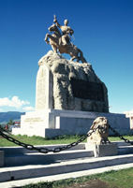

Karakorum:
Karakorum is one of the country’s major tourist destinations.
The site of Chinggis Khaan’s fabled city, administrative centre of an enormous empire, Karakorum was founded in 1220 in the Orkhon valley, at the crossroads of the Silk Road.
It was the seat of power of the Mongol Empire until Khubilai Khaan transfered it to what has nowadays become Beijing. The city was destroyed and its materials used to build the monumental 400m walls and 108 stupas that surrounded Mongolis's first Buddhist monastery of Erdene Zuu, built in 1586.
Inside the walls by 1792 there were 62 temples and 10.000 lamas, and stone turtles marked the boundaries, two of which can still be found.
Nearby are the Turkic monuments and rock inscriptions dating from the 8th and 9th centuries.

Gobi Desert:
The Gobi desert, in the south, is a vast zone of desert and desert steppe covering almost 30 percent of the country. The area is often believed to be a lifeless desert, but is actually mostly steppe, inhabited by camel herders, rich in wildlife.
Mongolians count 33 different sorts of gobi, and sandy desert makes up only three per cent.
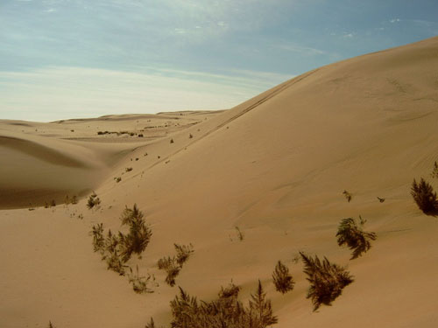

The temperature climbs to plus 40C in summer and as much below freezing in winters.
It is home to the bactrian (two-humped) camel, and Gobi people hold a camel festival and camel polo every year.
Here, in 1923, a US Natural History museum expedition led by Roy Chapman Andrews found the first nest of dinosaur eggs the world had ever seen.
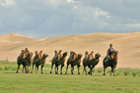

Khuvsgul:
Known as the Dark Blue Pearl, Lake Khuvsgul is Mongolian deepest lake.
In the northernmost aimag, its outlet is the largest tributary to Siberia’s Lake Baikal. At 1,645m above sea level, it is frozen from January until April or May, after which a ferry runs between Khatgal and Khankh, the northern and southern towns within the boundaries of the National Park. Here, shamanism survives as a religion among the Darkhads, and the Tsaatan reindeer tribesmen. Tourists can trace the lake shores by horse, foot or on ship Sukhbaatar.
Lake Khuvsgul is an important migration route for birds from Siberia, haven for birdwatchers. The Dayan Deerhiin cave has ancient wall paintings.

Gorkhi-Terelj:
Open all year, Terelj (meaning dahurian rhododendron) is a spectacular valley park only two-hour drive from Ulaanbaatar, with green meadows carpeted with a dazzling variety of edelweiss and other wildflowers, fascinating rock formations against a backdrop of pine-clad mountains and wooded streams.
It has been called ‘a museum of nature and the animal kingdom’.

Khan Khentii:
The homeland of Chinggis Khaan, Khan Khentii is covered with forests, taiga and mountain forest steppe.
It is described in The Secret History of Mongols, and is a protected area north-east of Ulaanbaatar.

Manzushri Monastery:
This is in a luxuriant valley of the Bogd Khan Mountain, Tuv Aimag, and an hour’s drive from Ulaanbaatar. The monastery was established in 1733 with 20 temples and 300 monks.
Destroyed in 1932, the only remaining temple has been restored and a museum tells its story. ]

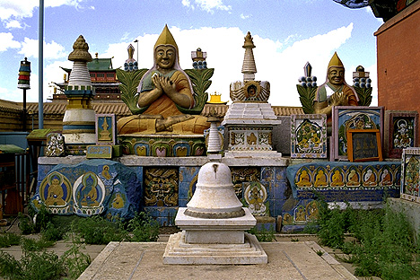

Khorgo:
Khorgo is an extinct basalt-covered volcano east of Lake Terkhiin Tsagaan National Park, Arkhangai Aimag, with interesting bubbles of solidified lava called the basalt gers.

Gun-Galuut:
Gun-Galuut Nature Reserve is truly the marvelous combination of mountains, steppes, pretty lakes, rivers and wetlands with its famous rare wildlife species. It is a home to the world endangered Wild mountain sheep-Argali, White-napped crane, Siberian White Crane, Hooded Crane, Swan Goose, Whooper swan and so on. Over 80 Argali sheep inhabit peacefully now and rare birds coming every summer in Gun-Galuut. Tourists visiting the Nature Reserve have the opportunities to do watching and taking photos of the endangered species, fishing, rafting and kayaking in the lakes and rivers, hiking, trekking and camping in the beautiful and peaceful nature, visiting nomadic family, riding horse, yak and camel and getting introduced to traditional nomadic lifestyle and culture. The reserve is only 2 hour drive from Ulaanbaatar to the east.

Shopping:
In Ulaanbaatar, there are a few duty free shops and restaurants where convertible currencies are accepted. In all other shops, local currency must be used. The best buys include pictures, cashmere garments, camel-wool blankets, national costumes, boots, jewellery, carpets, books and handicrafts. The notorious black market on the outskirts of Ulaanbaatar is a large, crowded flea market which sells a huge variety of items. Suitable for the adventurous traveller, it is patronized mainly by local people. Pickpockets can be a problem.
Shopping hours:
Mon-Sun 1000-1800 as a general guide although times and days vary considerably.

